TASK – 2

Goal
Fetch API data using Requests and display results properly.

Requirements
- Use requests module
- Parse JSON response
- Add search/filter

Deliverables
- Python script + GitHub link
- Screenshots of output

Code
import requests
import json
def fetch_and_filter_users(search_query=None):
"""
Fetches user data from a placeholder API, parses the JSON,
and optionally filters the results by name or company.
"""
url = "https://jsonplaceholder.typicode.com/users"
try:
# Send GET request to the API
response = requests.get(url)
# Raise an exception for bad status codes (44, 500, etc.)
response.raise_for_status()
# Parse the JSON response
users = response.json()
# If a search query is provided, filter the results
if search_query:
search_query = search_query.lower()
filtered_users = [
user for user in users
if search_query in user['name'].lower() or
search_query in user['company']['name'].lower()
]
else:
filtered_users = users
# Display the results cleanly
display_results(filtered_users)
except requests.exceptions.HTTPError as http_err:
print(f"HTTP error occurred: {http_err}")
except requests.exceptions.ConnectionError as conn_err:
print(f"Connection error occurred: {conn_err}")
except Exception as err:
print(f"An error occurred: {err}")
def display_results(users):
"""Helper function to format and print the user data."""
if not users:
print("\n No users found matching the filter criteria.")
return
print(f"\n Found {len(users)} user(s):")
print("-" * 60)
for user in users:
print(f"ID: {user['id']}")
print(f"Name: {user['name']}")
print(f"Username: {user['username']}")
print(f"Email: {user['email']}")
print(f"Company: {user['company']['name']}")
print("-" * 60)
if __name__ == "__main__":
print("--- Fetching All Users ---")
fetch_and_filter_users()
print("\n--- Fetching Users Filtered by 'Clementina' ---")
fetch_and_filter_users(search_query="Clementina")
print("\n--- Fetching Users Filtered by Company 'Romaguera' ---")
fetch_and_filter_users(search_query="Romaguera")
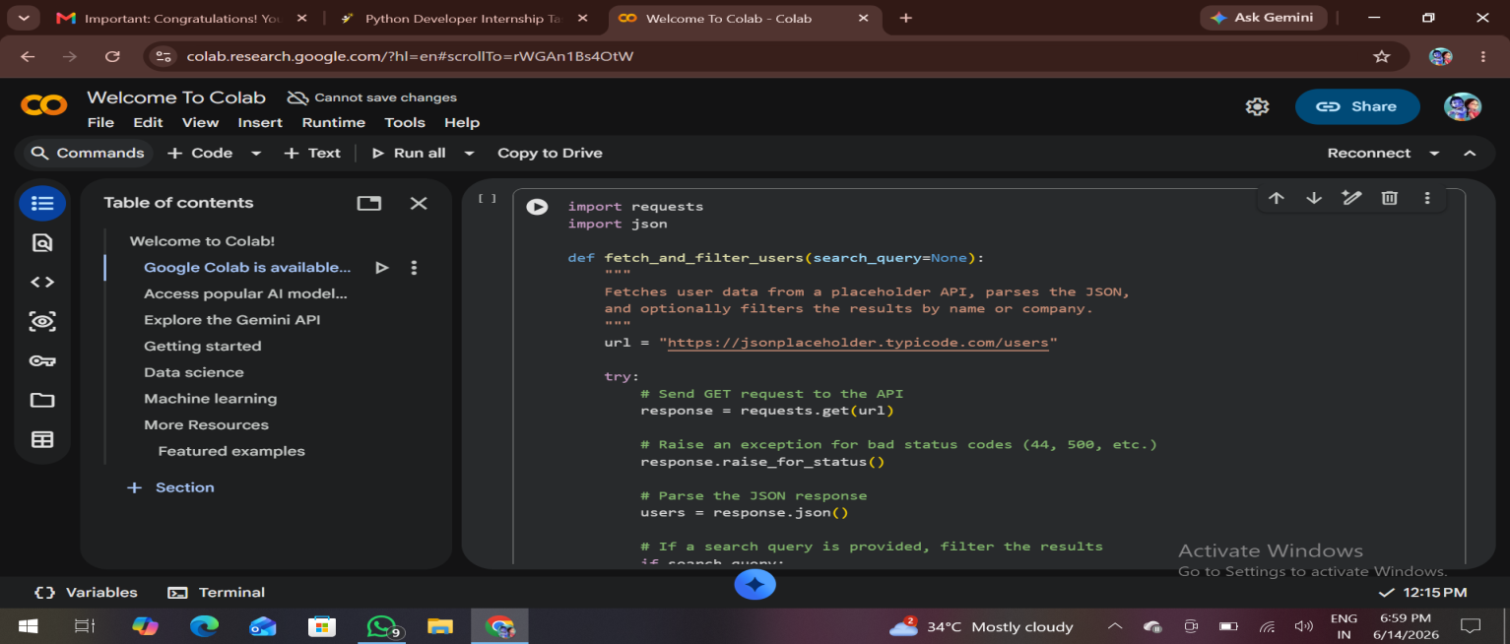

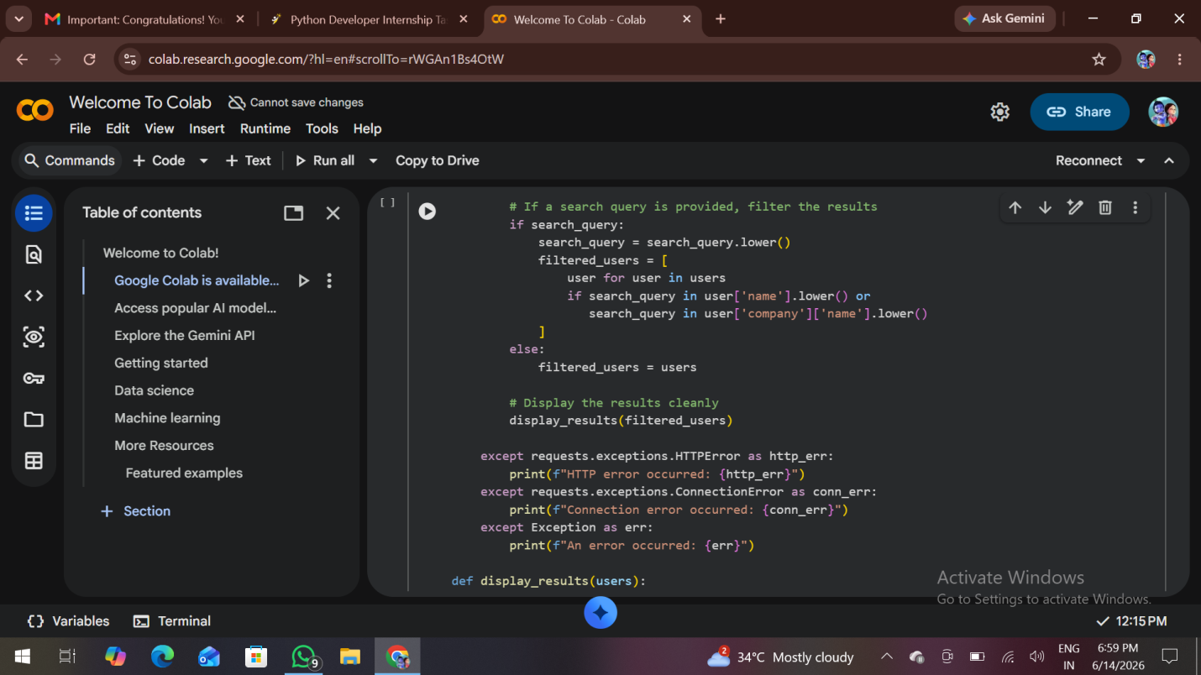

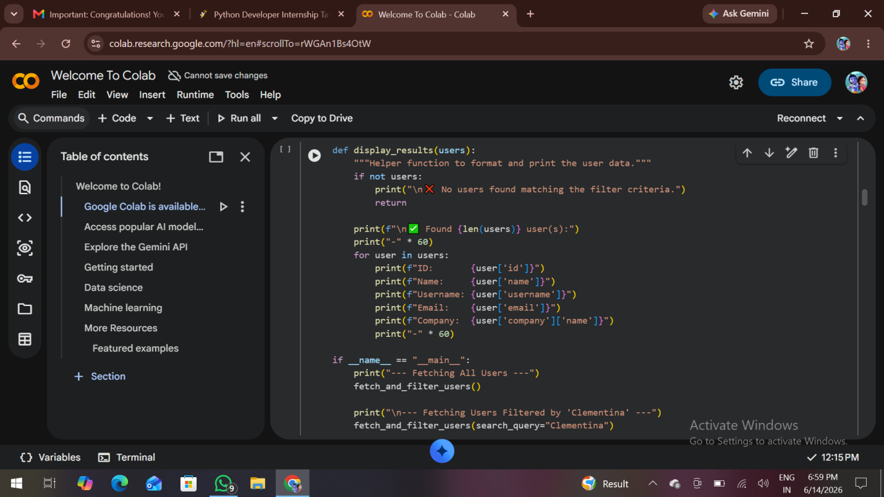

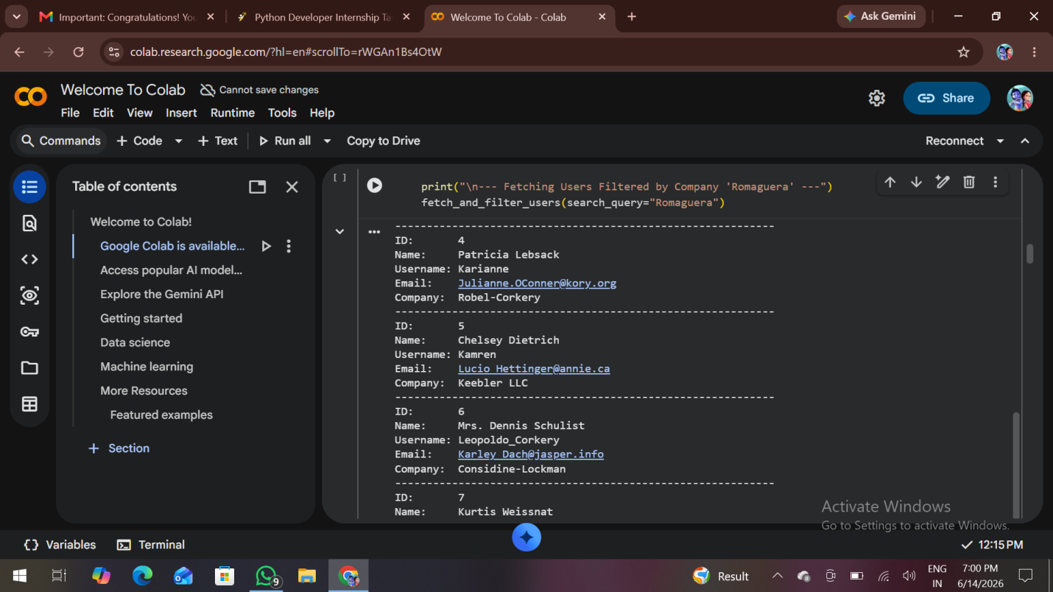

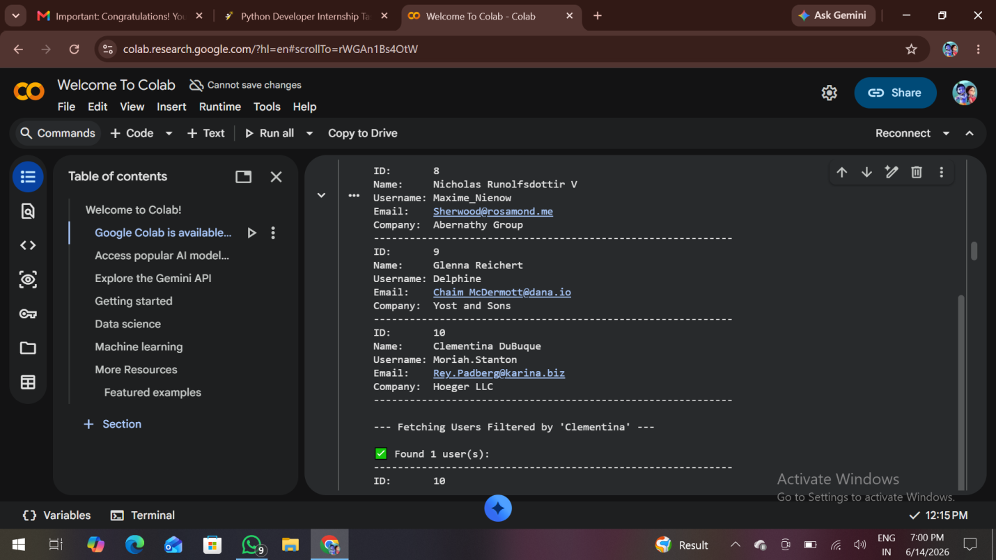

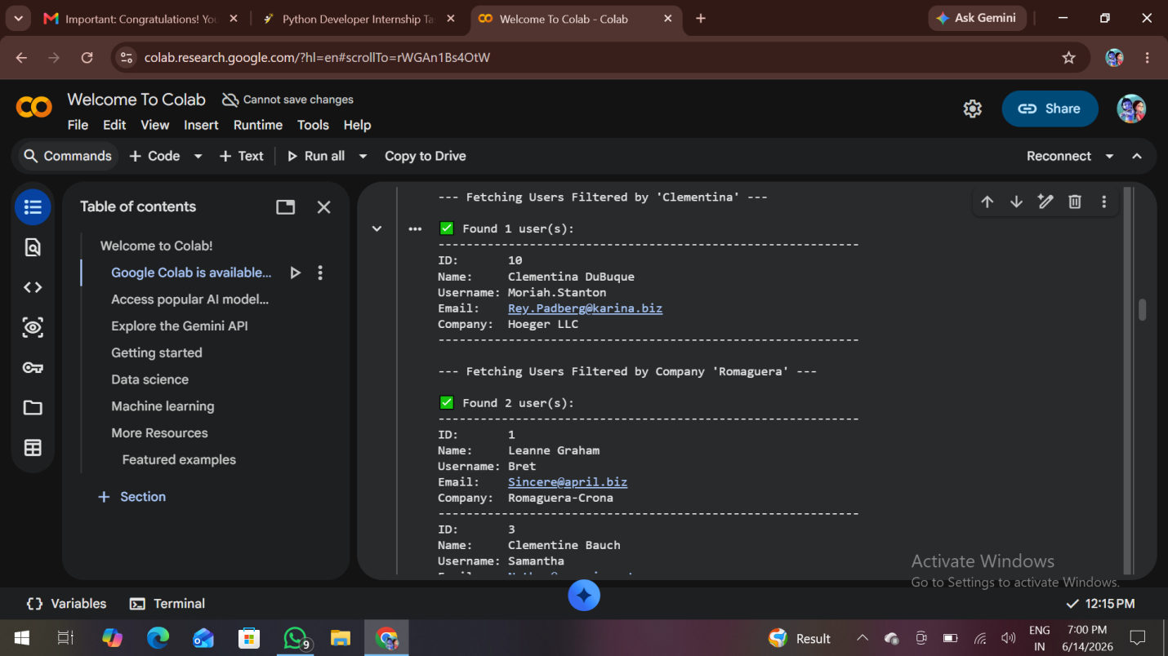

GitHub repository link…..
https://github.com/DanamPujitha19/InternSpark

Task link in GitHub….
https://github.com/DanamPujitha19/InternSpark/blob/main/TASK%202.docx

